**Day 23:**

**Running in Docker**

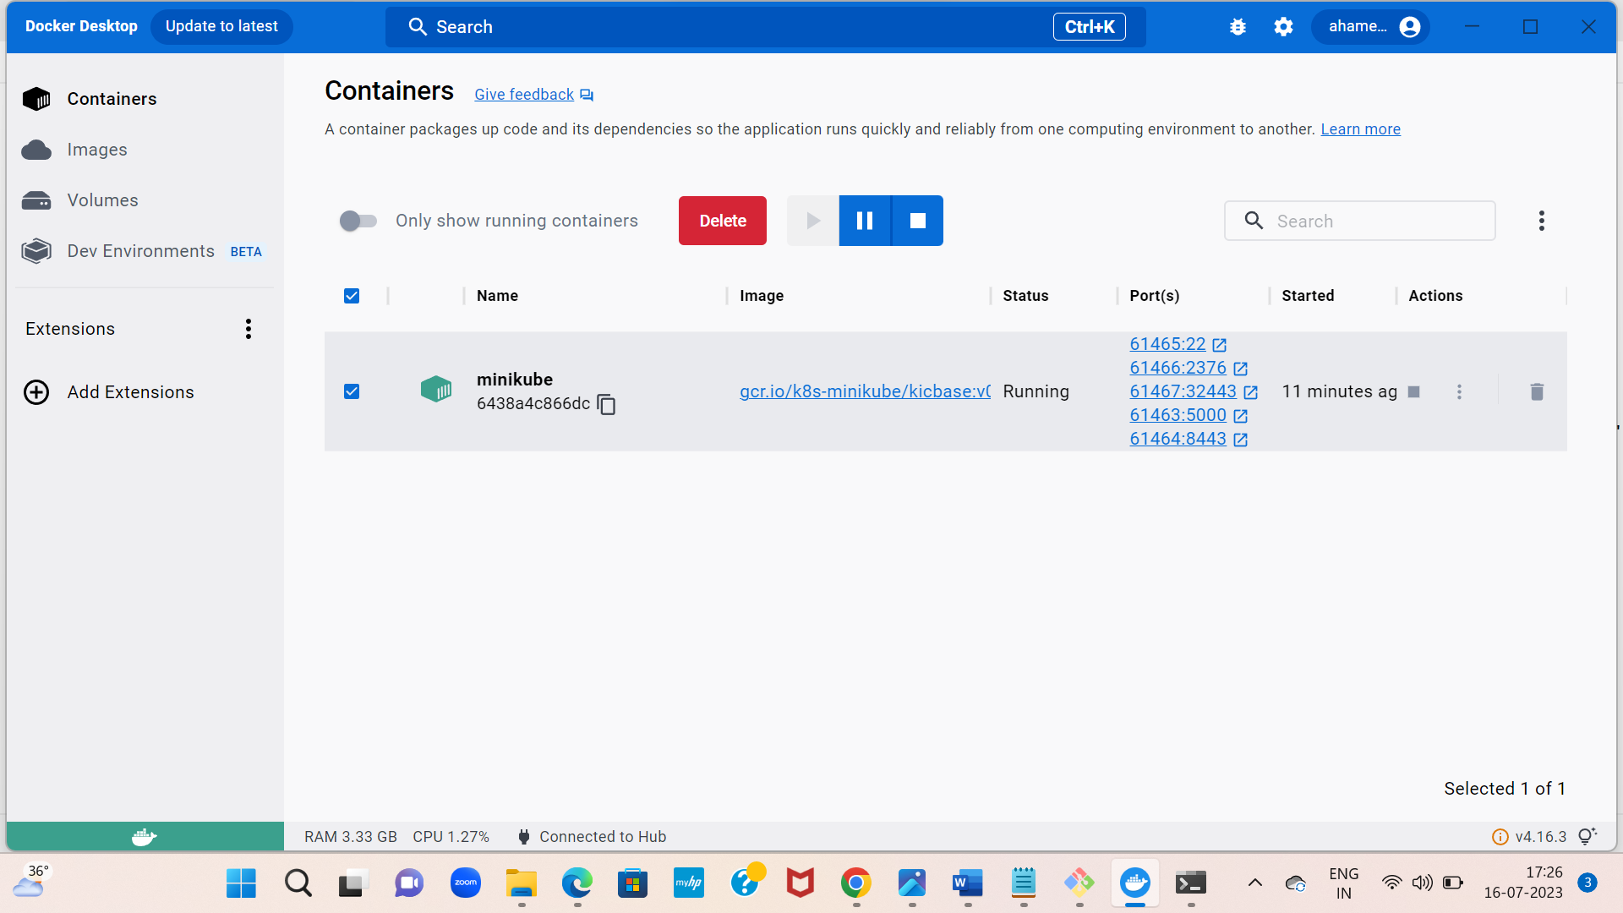

**Day 23:**

**Created a S3 bucket with public access as no**

**And monitoring the logs with cloud watch**

